Experiment 12
You are designing a Task Management System for a small team. The
system should include the following features:
1. User Login and Role Assignment
2. Task Creation and Assignment
3. Task Prioritization and Deadlines
4. Progress Tracking and Reporting
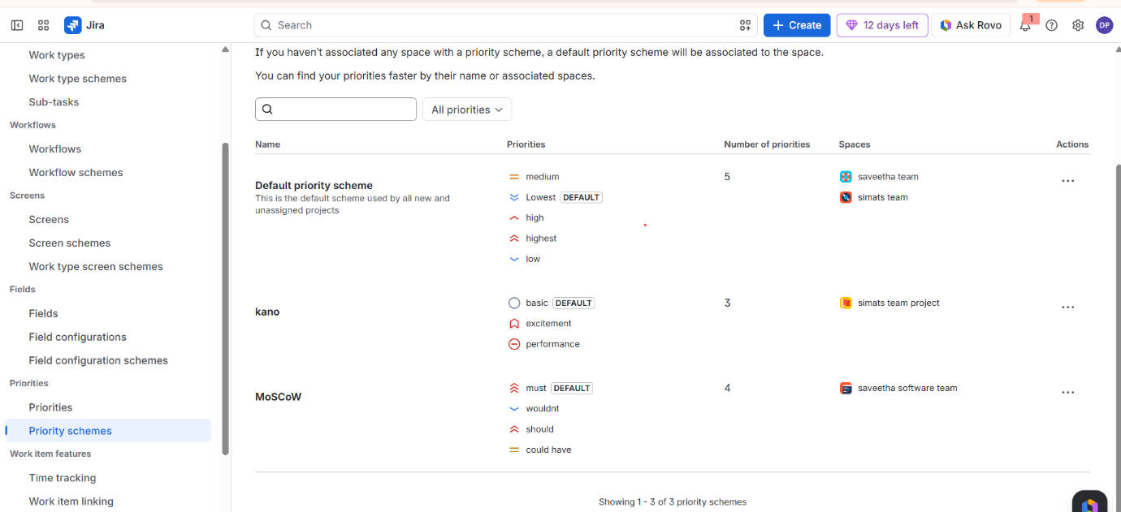
Prioritize these requirements using the MoSCoW and Kano models i
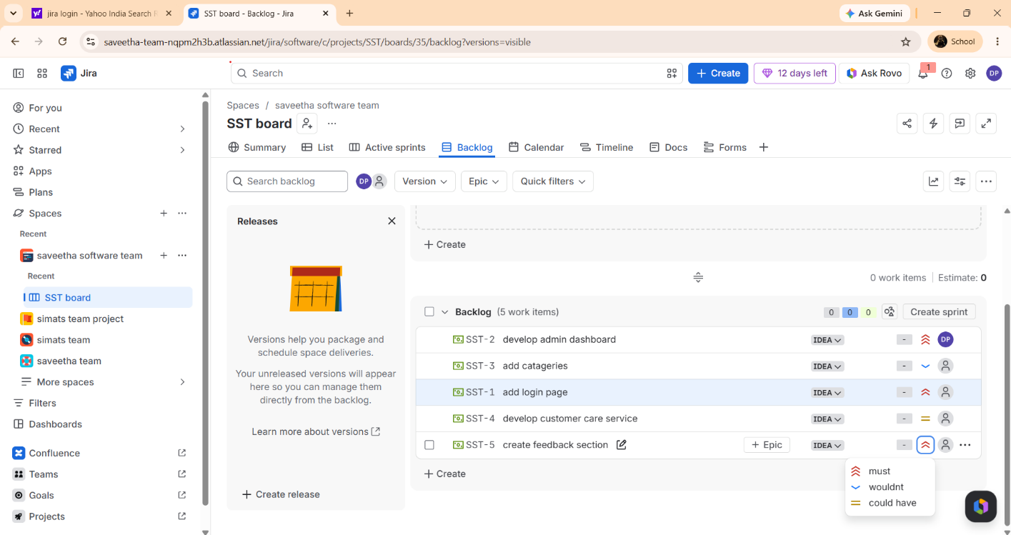
add backlog

start sprint
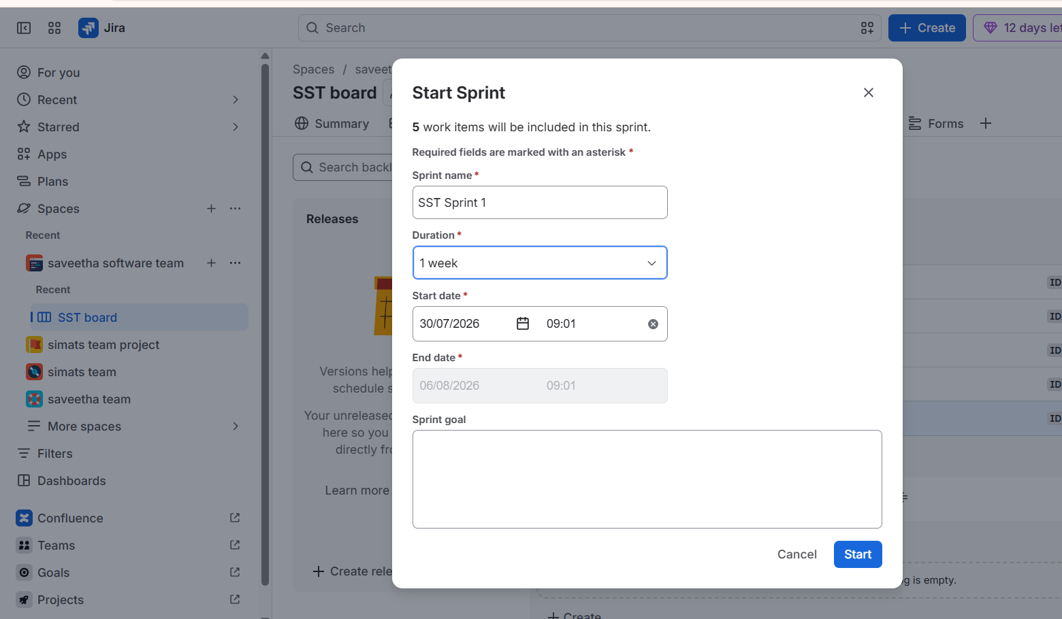
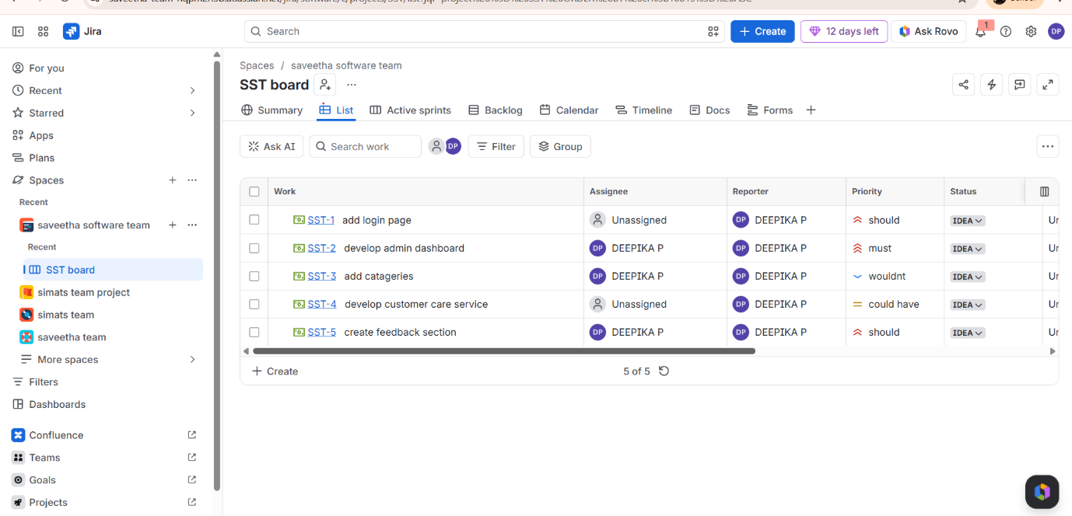
view the list

